Spring Data JPA - Quick Example
Implementation:
Country.java:
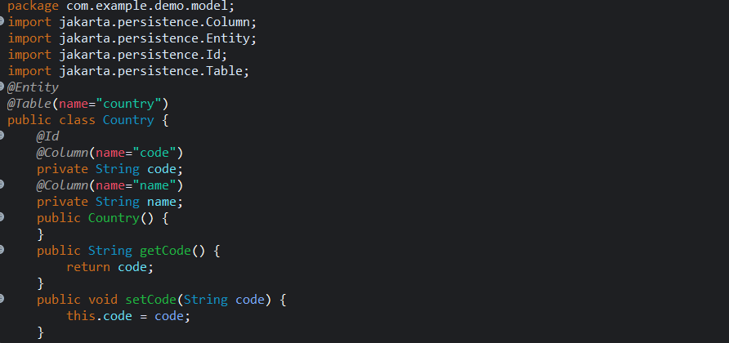
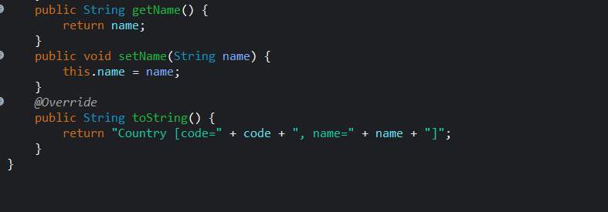
CountryRepository.java:
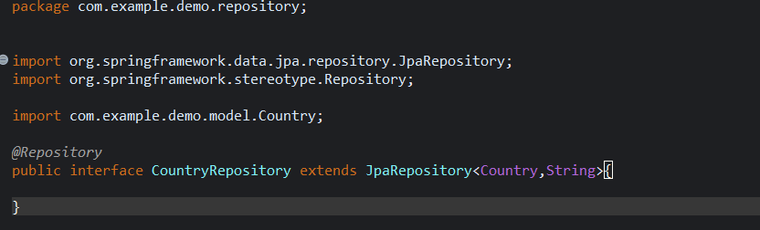

CountryService.java:
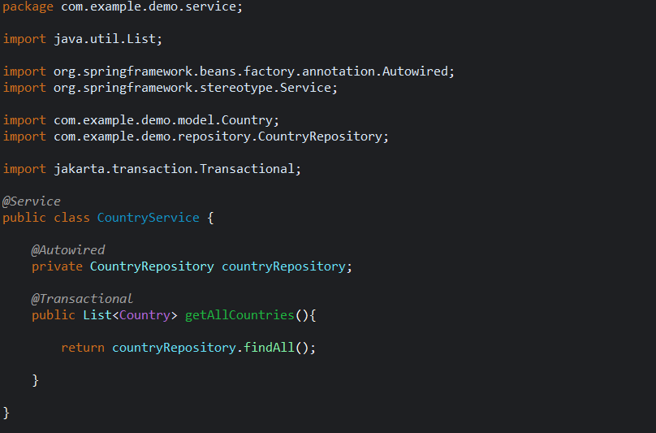
DemoApplication.java:
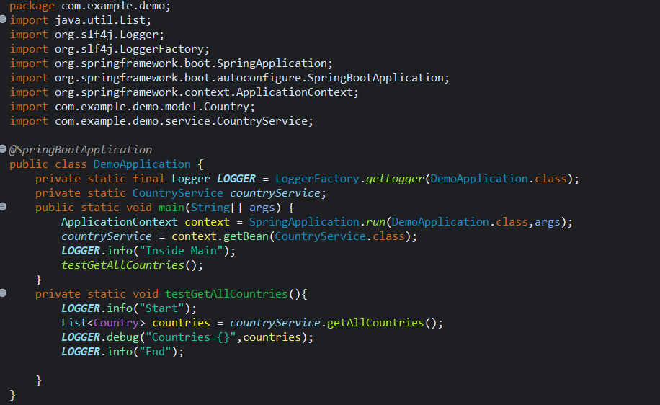

Application.Properties
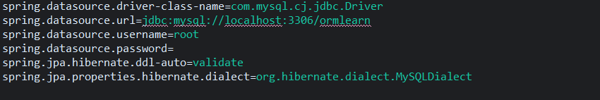

Output:
